Software Requirements Specification
for
Stream Gauge
Version 2.0 approved
Prepared by Timothy Harrelson and Jeremy Swartwood
Capstone Project, UAA
02/01/2018
Table of Contents
Table of Contents ii
Revision History ii
1. Introduction 1
1.1 Purpose 1
1.2 Intended Audience and Reading Suggestions 1
1.3 Product Scope 1
1.4 References 1
2. Overall Description 1
2.1 Product Perspective 1
2.2 Product Functions 2
2.3 User Classes and Characteristics 2
2.4 Operating Environment 2
2.5 Design and Implementation Constraints 2
2.6 User Documentation 2
2.7 Assumptions and Dependencies 2
3. External Interface Requirements 3
3.1 User Interfaces 3
3.2 Software Interfaces 3
4. System Features 3
4.1 Image Processing 3
4.2 Image Classifying 4
5. Other Nonfunctional Requirements 4
5.1 Performance Requirements 4
5.2 Software Quality Attributes 4
6. Other Requirements 5
Appendix A: Glossary 5
Appendix B: Figures 5

Revision History
Name | Date | Reason For Changes | Version
Timothy Harrelson Jeremy Swartwood | 02/01/2018 | Initial version | 1.0
Timothy Harrelson Jeremy Swartwood | 02/25/2018 | Add changes from classmates during review.  Add Figures from Visio diagram. | 2.0

Introduction

Purpose
The purpose of this project is to evaluate an image of a body of water and categorize the pixels as either non-water or water using a machine learning classifier.

Intended Audience and Reading Suggestions
The intended audience consists of two groups of people.
- The sponsor
- Development team

Product Scope
Benefits
- This product will make the process of automatically determining the height of water cheaper by only requiring lower quality instruments.
- Setup will be easier with a reduction in required infrastructure like a bridge for the audio or visual gauge.
- No required survey of land prior to installation.

Objectives
- Identify the water pixels from an image.
- Gathering and preparing usable data for training and validation.

References

Overall Description

Product Perspective

Currently the methods of identifying water height are expensive. In some instances this requires trained personal to interpret and gather data and survey land.

This will require much cheaper measuring instruments, less qualified personal, and low maintenance.

Product Functions
- The users will enter an image into the product.
- The product will return a set of data identifying which pixels are water within the image.

User Classes and Characteristics
The following groups will use the product:
- Researchers at NOAA and USGS
- Citizen science organizations

Operating Environment
Operation will be done on a Windows OS, with limited or non-existent GPU.

Design and Implementation Constraints
This product will be using Python with OpenCV. Images will be provided in JPG format.

User Documentation
A user manual will be created with the following information:
- The input format to the software.
- The commands to execute the software.
- The output format of the software.
- Details of how the software works will be described.

All code will be commented.

Assumptions and Dependencies
Assumptions:
- Python3 installed on the computer with all required modules.
- Images must be a reasonable size.
- Images are assumed to be within a reasonable lighting condition.
- Images can be in any standard image format accepted by OpenCV.

Dependencies:
- Numpy
  - Used for complex mathematical computations on array in python.
- opencv-python
  - Used for image processing and common Computer Vision algorithms.

External Interface Requirements

User Interfaces
This product will a Command Line Interface. There will not be a GUI produced.

Software Interfaces
Inputs:
Images in a standard image format are expected.

Outputs:
A binary mask where a 1 at a specific index in the matrix represents water at the pixel in the same location in the source image. Conversely 0 represents non-water.

System Features

Image Processing

Description and Priority
Analyzing images through the following process:
- Using a low pass filter with temporal differences to generate a mask.
- Use the mask to identify Regions of Interest (ROI). The mask indicates which type of feature is in the region.
- Use a Histogram of Oriented Gradients (HOG) algorithm to extract features from sub-sections of the ROI.
- Use the features from the HOG to train an Artificial Neural Network in an unsupervised fashion.

Stimulus/Response Sequences
A user will need to provide a batch of images to the Image Processor and start the process.

Functional Requirements
REQ-1: Images must be all in a single folder, or they will not be processed.
REQ-2: Images must be the same dimensions, if not an error will be presented to the user.
REQ-3: Images must be taken sequentially in time without large gaps.
REQ-4: Images must be named sequentially to match the order taken in time.
REQ-5: Images must be of the same site location and taken from the same camera position.

Image Classifying

Description and Priority
Classify sections of an input image (pixels) as either water or non-water.

Stimulus/Response Sequences
User provides an image to the software and gives the command to start the process.

Functional Requirements
REQ-1: If the host machine does not have software or modules installed an error message will be provided.
REQ-2: If an incorrect image format is provided, an error will be presented to the user.
REQ-3: If an image is too large or too small, an error will be presented.
REQ-4: When complete the software will produce a binary matrix the same size as the input image. Where each cell of the matrix signifying a pixel as water or not water.

Other Nonfunctional Requirements

Performance Requirements
User’s computers are assumed to be weak, meaning they won't have GPU or high Memory space.

Software Quality Attributes
Accuracy of pixel classification.

Other Requirements
Appendix A: Glossary
Pixel Classification - A machine learning algorithm that determines if a pixel falls into a specific category.
HOG - Histogram of Oriented Gradients
ROI - Regions of Interest
ANN - Artificial Neural Network

Appendix B: Figures

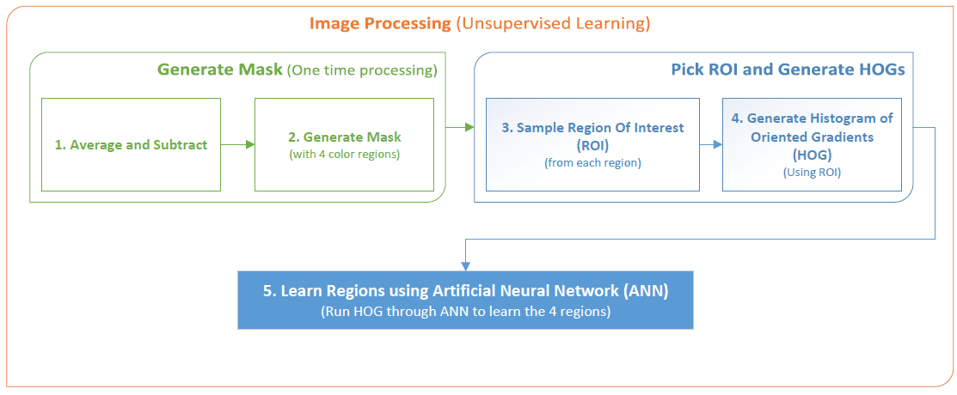
Figure 1 – Overview for Image Processing

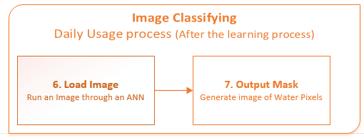
Figure 2 – Overview for Image Classifying

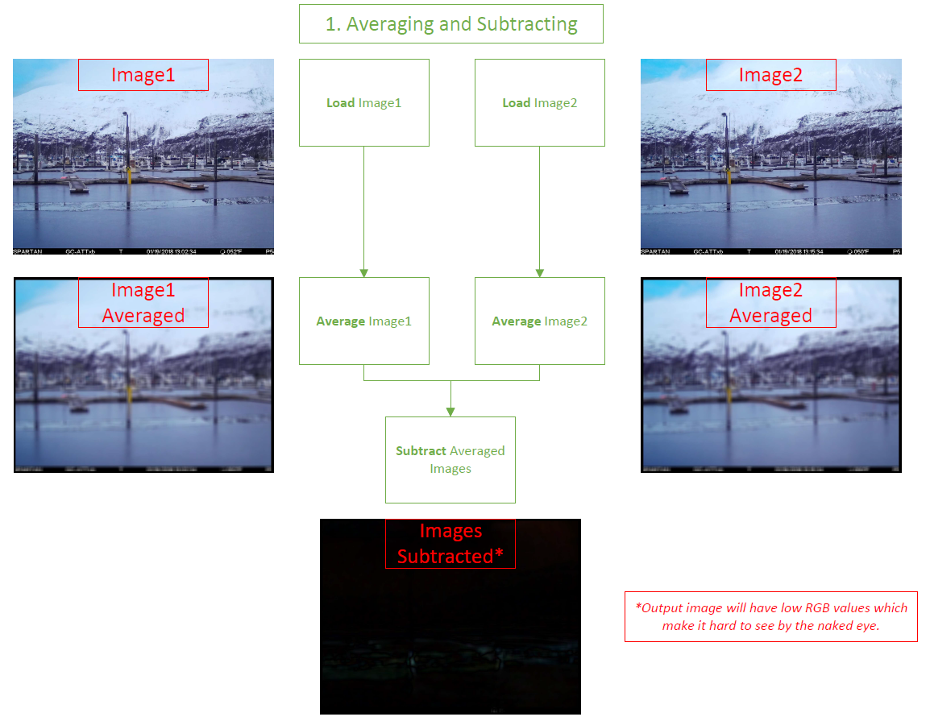
Figure 3 – Process of applying low-pass filter for Image Processing

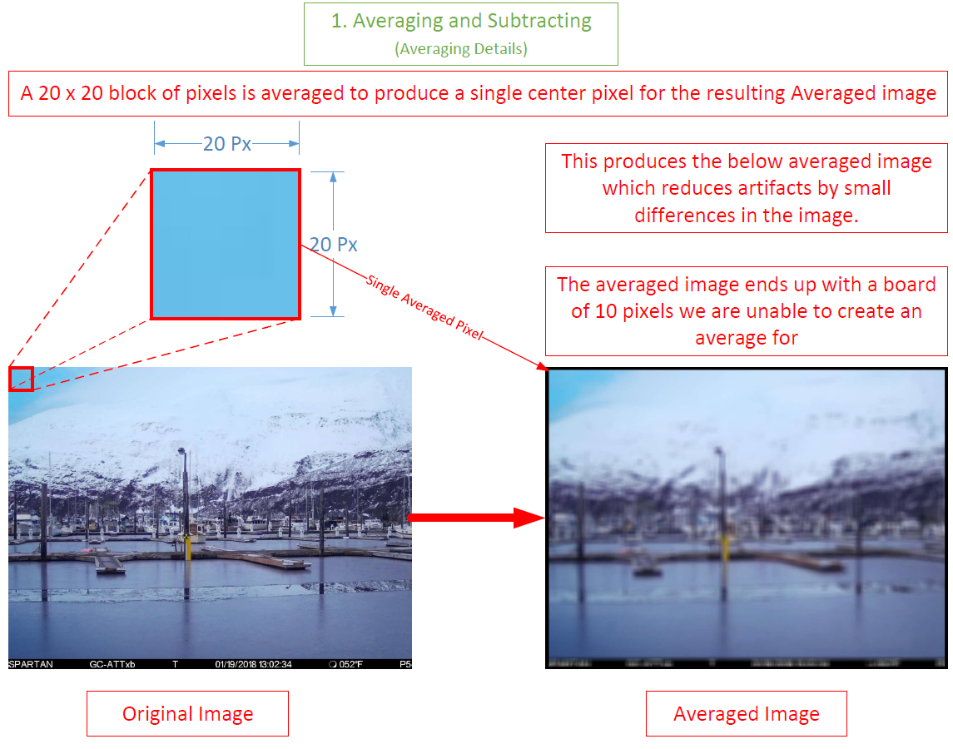
Figure 4 – Details regarding the low-pass filter averaging.

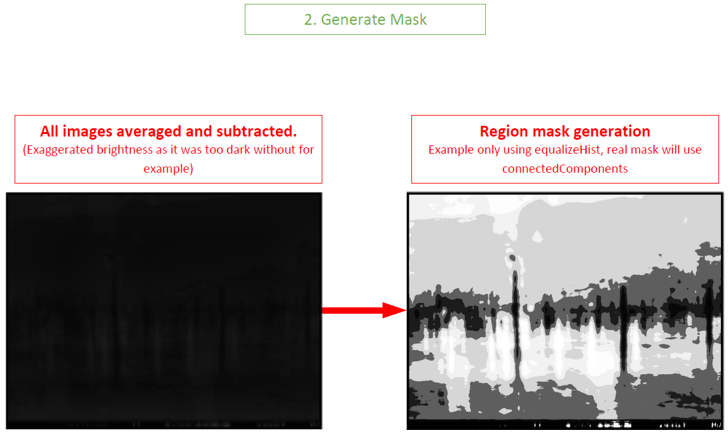
Figure 5 – Process of generating an output mask.

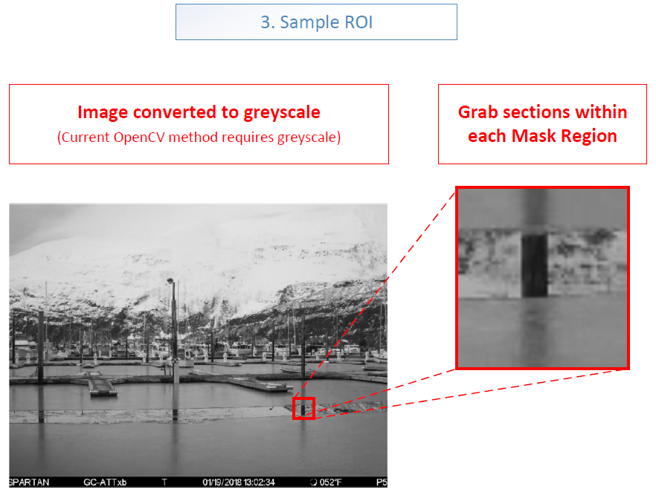
Figure 6 – Process to sample sections of an image to generate HOGs for.

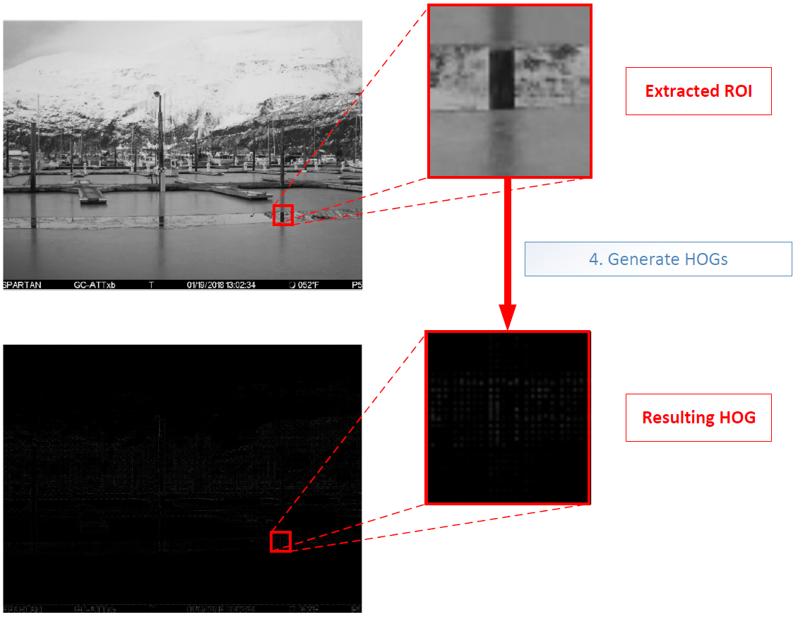
Figure 7 – Example on how extracted ROI are turned into HOGs.

